Chapter 12, Problem 71.

In Fig. 12.73, two wattmeters are properly connected to the unbalanced load supplied by a balanced source such that V_{ab} = 208 ∠0° V with positive phase sequence.

(a) Determine the reading of each wattmeter.
(b) Calculate the total apparent power absorbed by the load.

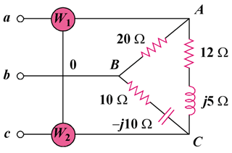

Figure 12.73
For Prob. 12.71.

